Hive organizes tables into partitions. It is a way of dividing a table into related parts based on the values of partitioned columns such as date, city, and department. Using partition, it is easy to query a portion of the data.

Query response time will become fast. because instead of looking whole data. It will look only respective column.

**Partitioning will create sub directories with in a table**

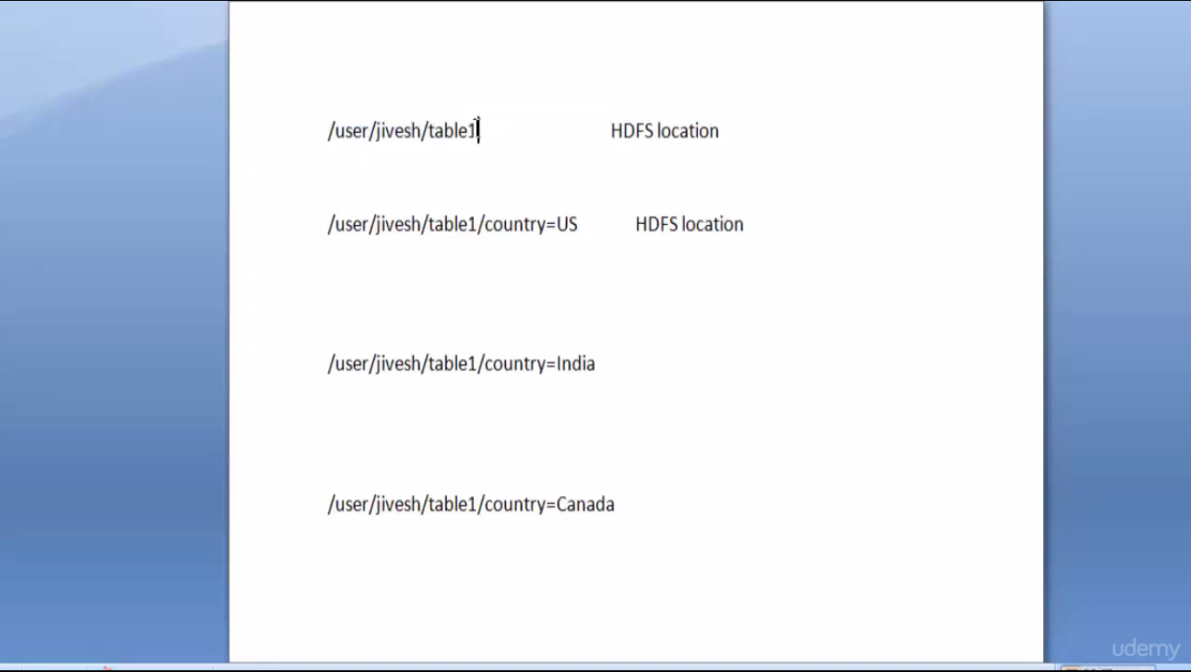

Fig Partition by country

2 types of partitioning

Static

We have to explicity hard code the partition colum while loading the data

Dynamic

These can be divided into internal and external tables

Part file contains data of 2012 and part2 contains data of 2013 . so I will load part file data in 2012 partition and part2 file in 2013 partition. See fig below

Part.txt

1, gopal, TP, 2012

2, kiran, HR, 2012

Part2.txt

3,kaleel,SC,2013

4,Prasanth,SC,2013

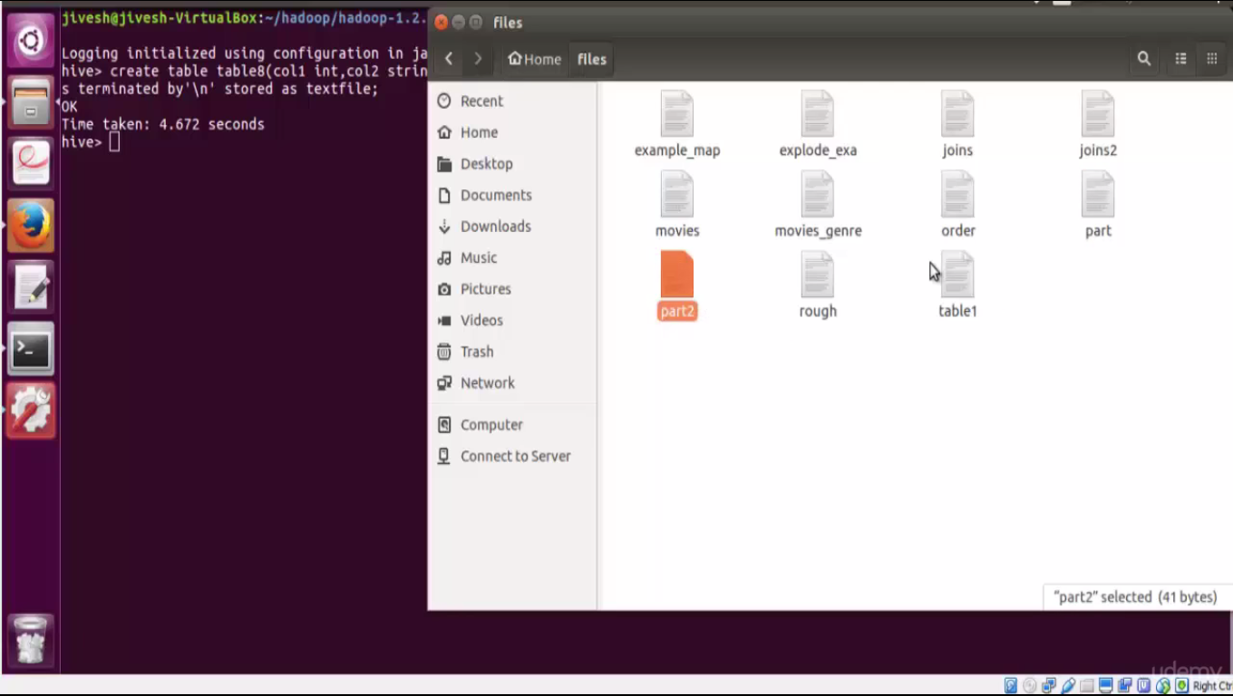

create table if not exists table4(col1 int,col2 string,col3 string)partitioned by (year int) row format delimited fields terminated by',' lines terminated by'\n'stored as textfile;

load data local inpath'/home/jivesh/files/part'into table table4 partition(year=2012);

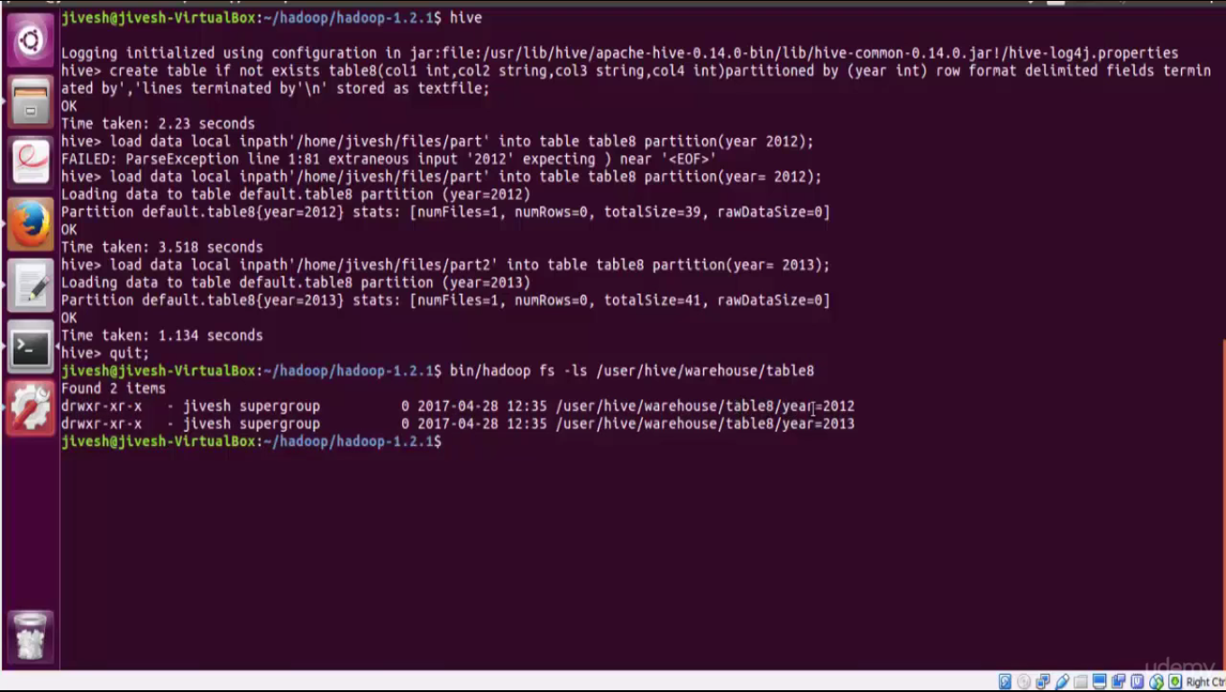

In static partition we have to load each partition with single sql statement which will result in writing a lot of sql statements for large no. of partitions

Hive introduces dynamic partition to overcome this problem.

In dynamic partition we can add any no of partition with single sql statement and we don’t need to hard code the partition value .we just pass col name of partition. Hive will automatically create partitions and loads data

By default dynamic partition is disabled in hive. We need to enable it

set hive.exec.dynamic.partition=true;

set hive.exec.dynamic.partition.mode=nonstrict;

in strict mode we have to specify at least one static partition along with the dynamic partition .

In this example we are not using static partition col. So we made it to nonstrict

Table 9 is non partition table.

Loading data into partition table (table10) from normal table (table9)

The col which we need to do partition must to keep in last in select statement

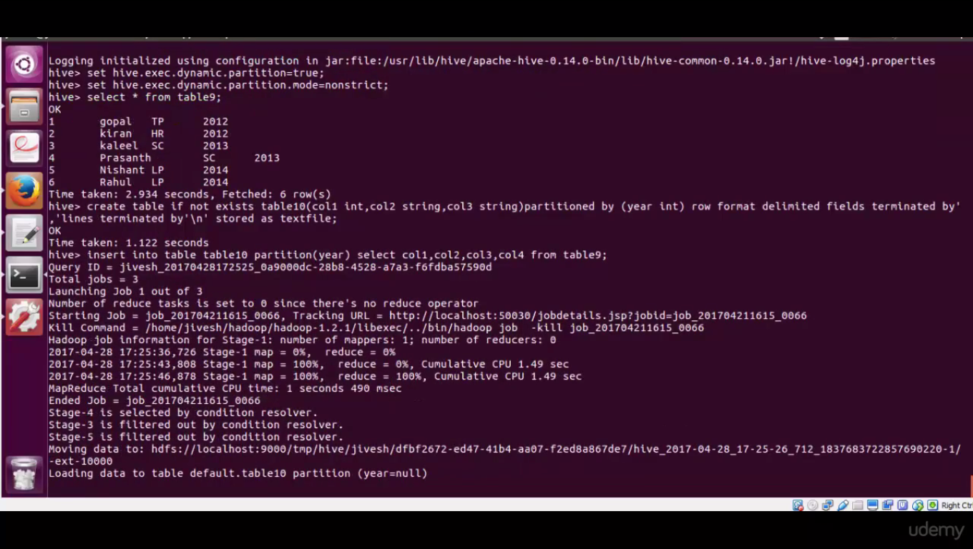

Col4 must be last in select statement because we are partitioning table with col4 // here col4 is year, which is a partition

List partitions:

Show partitions table10;

Limitation:

Creating too many partition is not a good idea. Because it will create large no of dir in hdfs, which is a overhead to namenode to keep the meta data of it . overall it makes our cluster slow and time consuming.

Go for dynamic partition only if you know values for partition column only when loading data into hive table

Go for Static partition only if you know values for partition column well in advance

------------------------------------------------------------------------------------------------------------------------------------------------------------

Partition.txt

create table if not exists table4(col1 int,col2 string,col3 string)partitioned by (year int) row format delimited fields terminated by',' lines terminated by'\n'stored as textfile;

load data local inpath'/home/jivesh/files/part'into table table4 partition(year=2012);

DYNAMIC PARTITIONS

set hive.exec.dynamic.partition=true;

set hive.exec.dynamic.partition.mode=nonstrict;

create table if not exists table5(col1 int,col2 string,col3 string,col4 int) row format delimited fields terminated by',' lines terminated by'\n'stored as textfile;

load data local inpath'/home/jivesh/files/dynamic'into table table5;

create table if not exists table6(col1 int,col2 string,col3 string,col4 int)

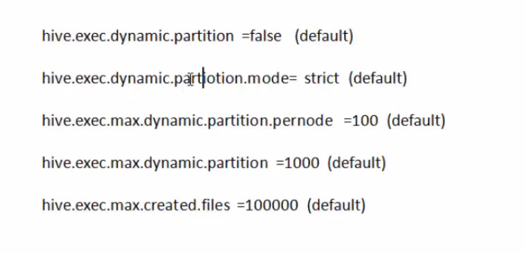

Default dynamic is not enabled . to use dynamic partition enable it

In Strict mode there should be alteast one static partition along with n no. of dynamic partition, because user may accidentally override all the partitions to dynamic and having all dynamic partition may result in more no. of partition, which will give problem to name node.

Max no. of dynamic partitions that can be created in each mapper and reducer node

Total no of dynamic partition allowed to be created in our cluster

Max no. of hdfs files that can be created gloabally by all the mappers and reducers

create table10 and load

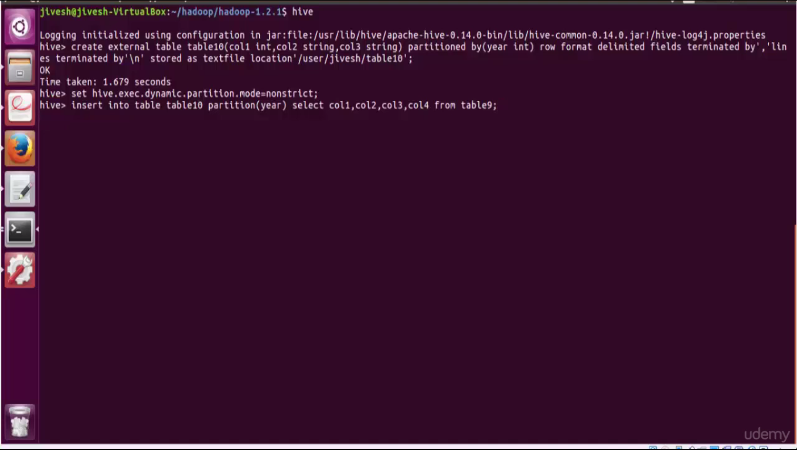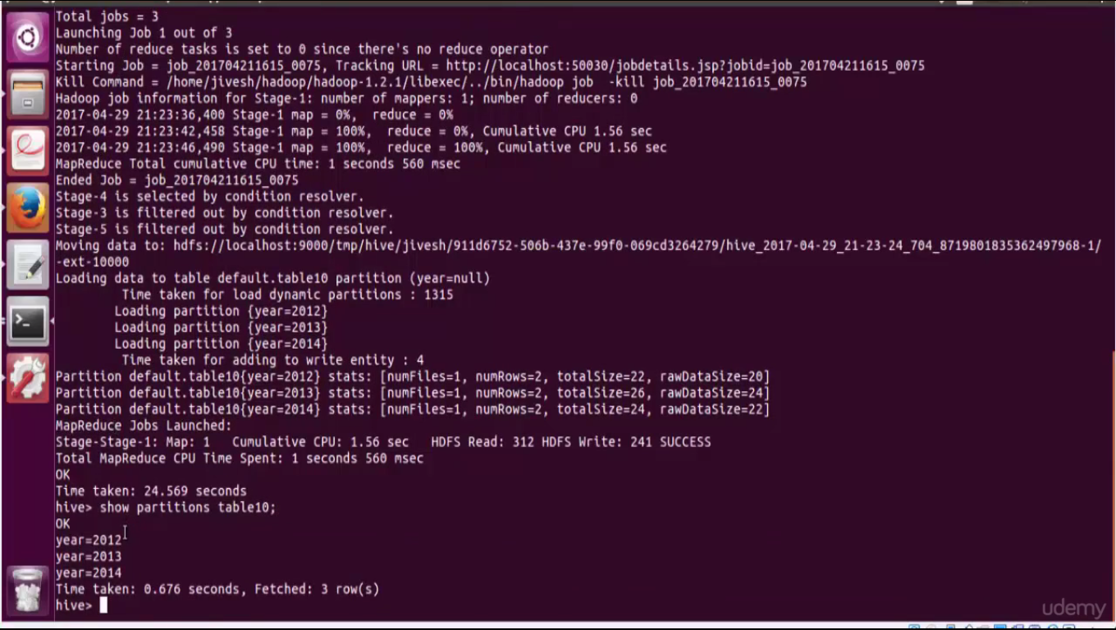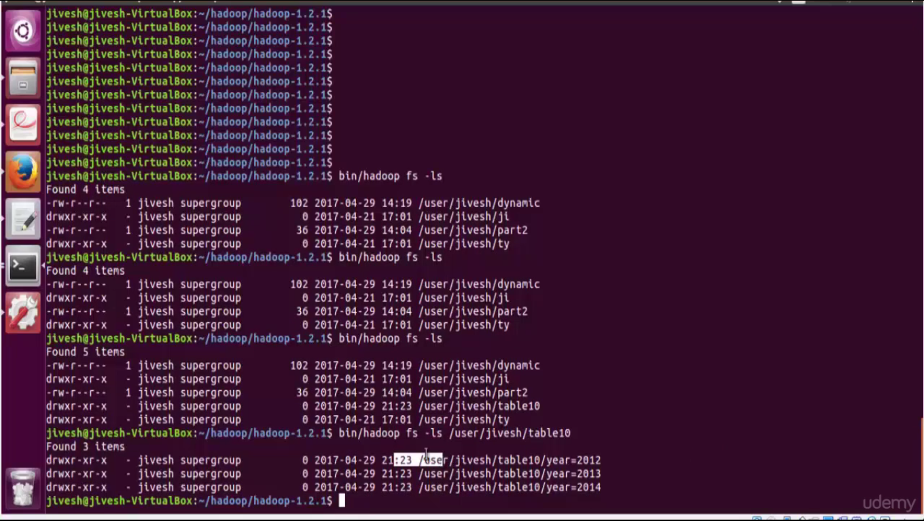

Dropping a partition

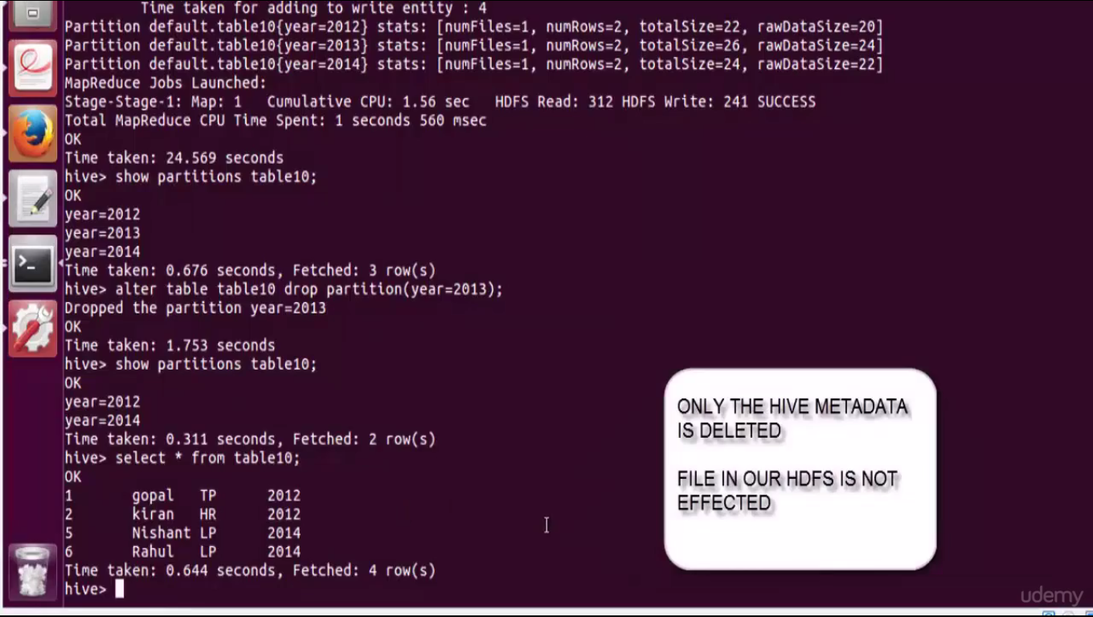

alter table table10 drop partition(year=2013);

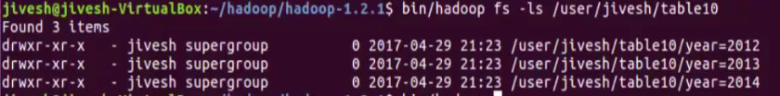

Add a partition in our external table

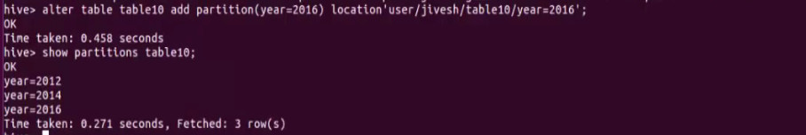

This is an empty partition





Hive does not have meta data of partition of 2017. So it is not showing from hive.

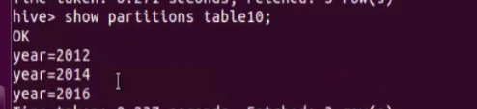

Recreate metadata for table10. So year=2017 will come in metadata.

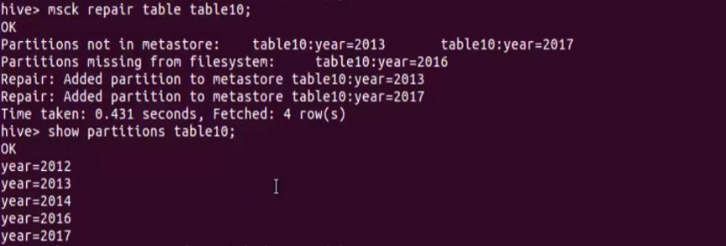

This will create metadata for 2013 also, because it was not deleted from hdfs previously. Only metadata got deleted . hdfs file was still available

Tables or partitions are sub-divided into buckets, to provide extra structure to the data that may be used for more efficient querying. Bucketing works based on the value of hash function of some column of a table.

We can use bucketing alone without partitioning but, gives best results when bucketing used with partitioning

Example:

We have a table which is partitioned on state i.e, we have each partition for every state but, with in a state there can be so many records for cities. In this case we can bucket the table by city column . so with in a state partition all the same citys should go into same bucket .

Each bucket may contain n number of cities but all the cities with same name will be in one bukect. Eg. Bucket1: hyd, del , Bucket2: bang, Chen ; hyd will not go to bucket 2.

Buckets should be 2^n

No. of reduce tasks = no. of buckets

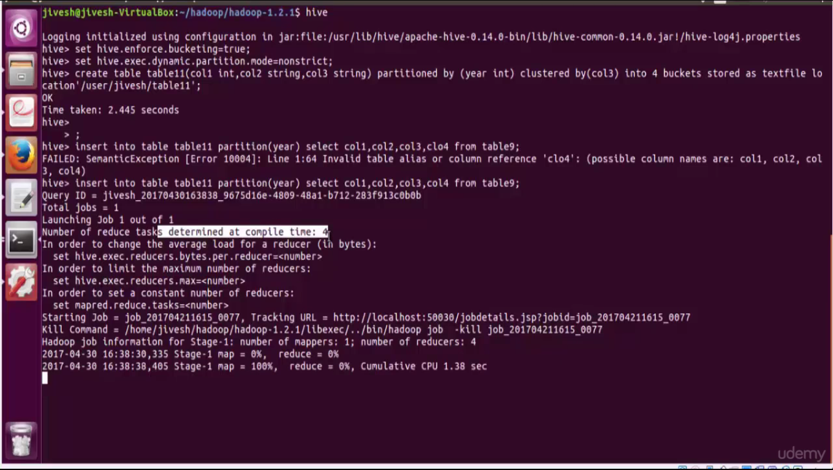

hdfs location

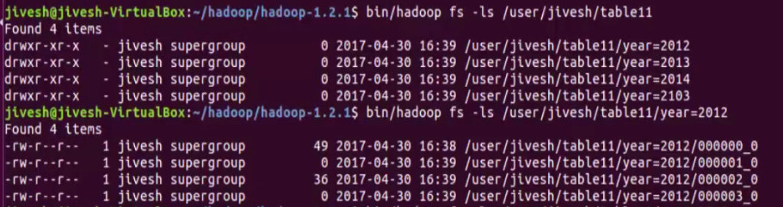

* **Bucking provides significant performance than partitioning when we have more unique sets of records in a table. Because in that case there will be a lot of partitions but in bucking we are providing the no. of buckets explicitly.**

*i.e, 1. emp id is diff for every one so more unique sets (:P) // just for understanding*

*2. many street name in city. So many unique sets(names) //if used partitioning for every street name a dir will be created*

* As data files are equal size parts map side joins are much faster
* Table sampling will be performed more efficient way

Limitation:

Data loading in bucketing is to be handled by us. It does not ensure data is properly loaded or not.

Syntax:

BUCKETING

set hive.enforce.bucketing=true;

set hive.exec.dynamic.partition=true;

create table if not exists table5(col1 int,col2 string,col3 string,col4 int) row format delimited fields terminated by',' lines terminated by'\n'stored as textfile;

load data local inpath'/home/jivesh/files/bucket'into table table5;

create table if not exists table10(col1 int,col2 string,col3 string,col4 int) clustered by(col2) into 4 buckets stored as textfile;

insert into table table10 select col1,col2,col3,col4 from table5;

create table if not exists table11(col1 int,col2 string,col3 string)partitioned by (year int) clustered by(col2) into 4 buckets stored as textfile;

insert into table table11 partition(year) select col1,col2,col3,col4 from table5;

Table sampling:

Take a sample data from across the table

Limit takes first n records not from all over the data

Table 10 is partitioned on 4th col and bucketed on 3rd col 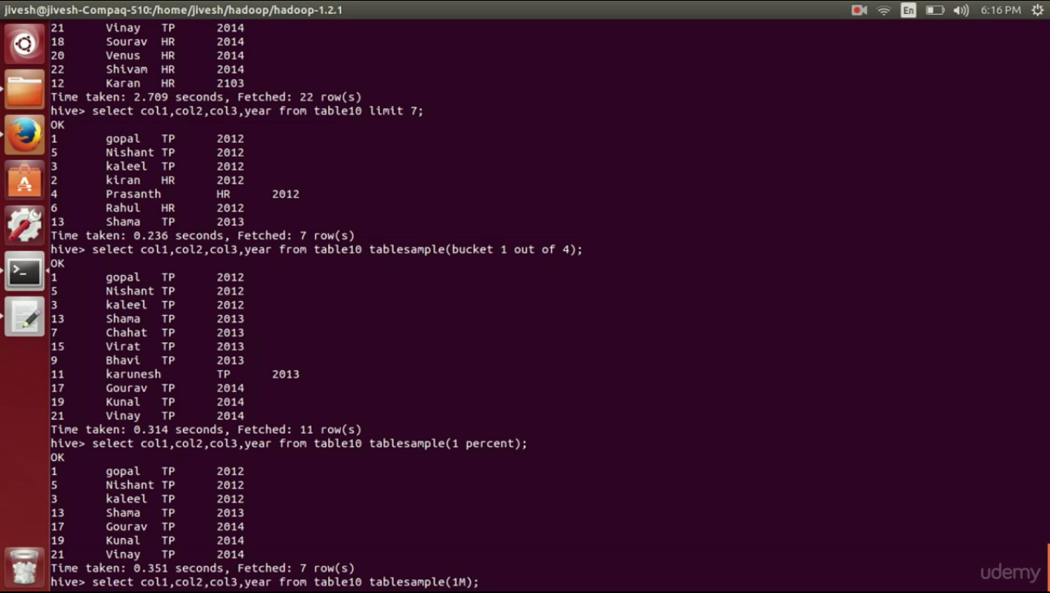

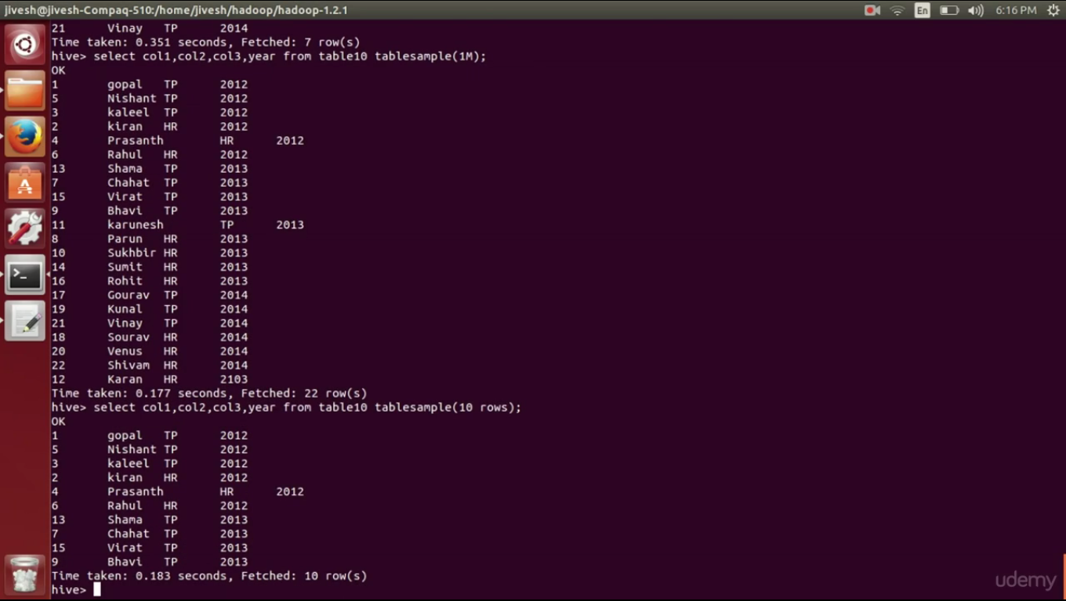

No_drop:

We can enable table from being dropped

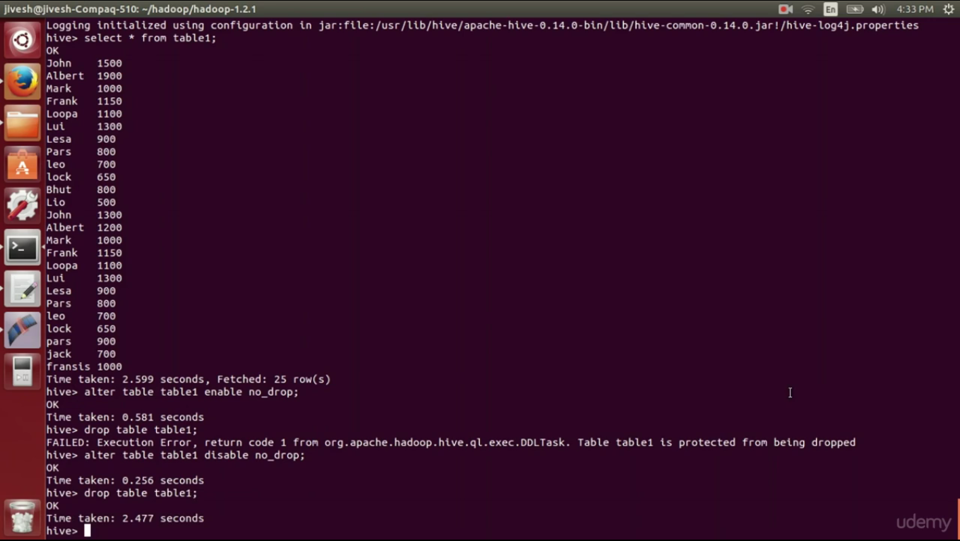

We can enable partition from being dropped

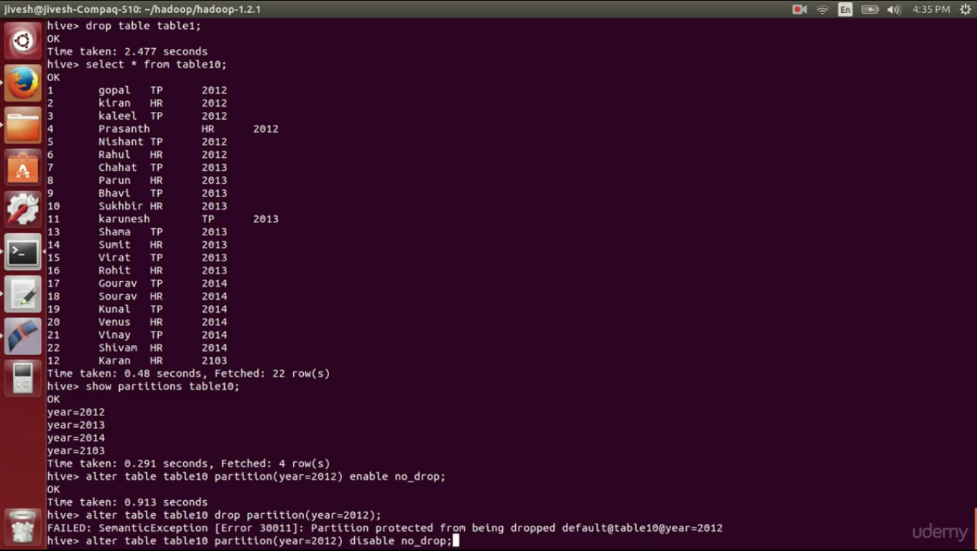

We can disable any table or partition from being queried

Offline:

alter table table2 enable offline;

